The Queen Elizabeth Olympic Park: Environmental Impact Over Time
This lesson/activity plan is designed to be taught in situ inside Queen Elizabeth Olympic Park. They have been designed by an experienced teacher for use with young people aged between 11 and 14 and they are aligned with the National Curriculum for Key Stage 3. The plan can be comfortably completed in a half-day visit. It includes two sites and involves a 0.6mile walk through the Park.

Preparation/required resources
For background and additional information about other park features you may find bookmarking the online (and mobile phone friendly) Groundbreakers map and guide useful. The latest Park map (including location of toilets and cafes) can be found on the Queen Elizabeth Olympic Park website and the site also advertises any events that may have an impact on your visit.
This activity plan includes the possibility of watching two short videos. A tablet or laptop is required should you wish to include these, and an external (eg Bluetooth) speaker might also be useful (there is free wifi available in the Park). These videos also feature in an Augmented Reality tour which is accessible with a mobile phone, but this might be difficult in a school group situation.
Otherwise you just need to print out the accompanying worksheets and provide pencils/pens.

Objectives
To give pupils a sense of the historical development of the area.
To help pupils understand that the environmental impact of human activities changes depending on the activity.

Location 1: London Aquatic Centre
Find the benches facing the Aquatic Centre outside the Podium. Pupils can be seated.

Activity 1: Timeline
Select three pupil volunteers. Pupil A stands at one side. Pupil B marks out 22 steps from pupil A. Pupil C stands at step 21.
Figure 1: Pacing out a timeline
Explain to the class that we will be looking at the history of the site. Each of the 22 steps represents 100 years. Therefore, pupil A represents the iron-age 2,200 years ago. Pupil C represents the industrial society 120 years ago and pupil B represents the present.

Activity 2: imagining life in an Iron Age village
Explain that before the Aquatic Centre was built, archaeologists discovered the remains of an Iron Age village where it stands now. Split the group into pairs. Ask them to talk to a partner and come up with three features of life in an Iron Age Village. Pupils feed back to the class.
Teacher collates feedback, corrects misconceptions and asks pupils to consider the environmental impact of the aspects of life in an iron-age village e.g. Transport? Building materials? Food?
Would the impact of these features have on the environment be small or large? Positive or negative?

Activity 3: Viewing an artist’s recreation of the Iron Age Village
Ask the pupils watch this video on your tablet(s) or laptop(s): Groundbreakers: London Aquatics Centre
If this cannot be done at the site, it should be done in school before the visit. (Activity 2 will then be a useful recap).

Activity 4: Iron Age village worksheets
Pupils are given the sheet ‘Environmental Impact of an Iron Age Village’. In pairs pupils use their knowledge to add various environmental impacts onto the sheet.
Some pupils may need teacher support by asking key questions:
- How did they get heat? And light?
- How did they travel?
- What were the buildings made from?
- Are the impacts small or large?
- Are the impacts positive or negative?
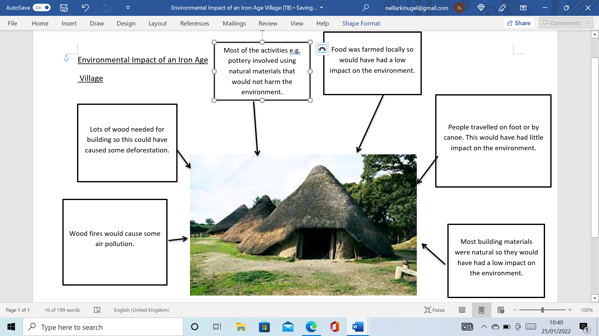
Figure 2: the teacher’s version of the worksheet

Key Points to Summarise
- Iron Age settlements used local, natural resources to meet their daily needs.
- These activities would have had a detrimental affect on the environment but on a relatively small scale e.g. burning wood for heating would have given off some air pollution.
- The iron-age villagers had a vested interest in looking after the resources in their environment e.g. not using up all of the wood so that they could harvest more next year.
- In the wider scale of human development, this is a relatively low-impact and sustainable society.

Activity 5: Aquatic Centre worksheets
Pupils then move forward in time to the present day and consider the sheet ‘Environmental impact of the Aquatic Centre’. Pupils consider the same questions:
- How do they get heat? And light?
- How do they travel?
- What is the buildings made from?
- Are the impacts small or large?
- Are the impacts positive or negative?
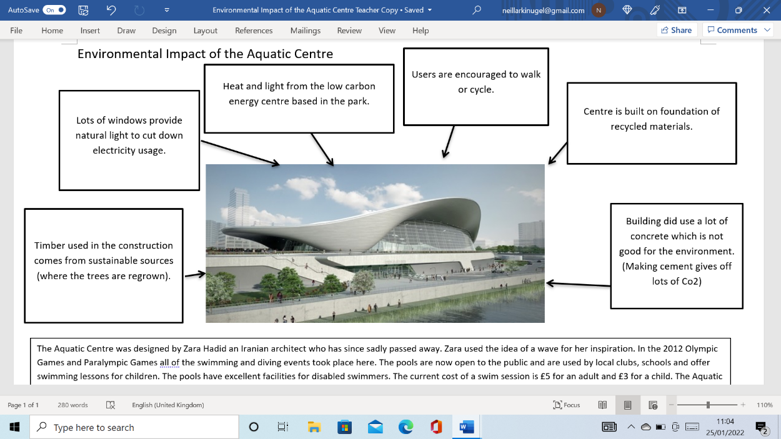
Figure 3: the teacher’s version of the worksheet

Key Points to Summarise
- The environmental impact of the building is a big consideration in its design.
- The architect and builders have tried to create a sustainable building.
- The building does have some features that impact negatively on the environment so is not perfect (e.g. it used a lot of concrete) but overall the building shows a commitment to sustainability.

Location 2: the canal-side area of the East London Energy Centre
Pupils walk approx. 0.6 miles through the Olympic Park towards Hackney Wick and stop at the East London Energy Centre which is on the site of the old Clarnico Sweet Factory. The junction of White Post Lane and Bassett Lane has a safe space away from traffic sufficient for up to 30 pupils.
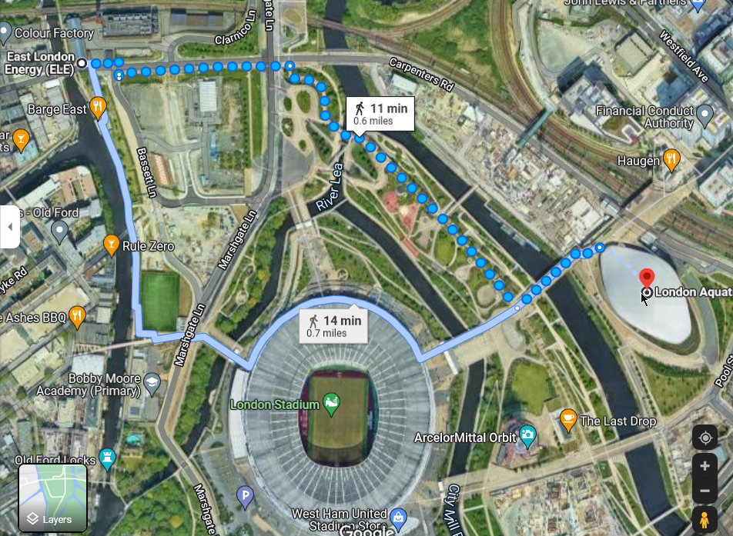
Figure 4: Satellite image showing distances from London Aquatics Centre to East London Energy. Various other routes could be taken through the park. Allow additional time for the slow pace of group walking.

Activity 6: imagining life in the Clarnico sweet factory
Pupils are asked to imagine life in a sweet factory 120 years ago in 1900. To help their thinking you may wish to point out the older buildings here that were part of the Clarnico complex. With original buildings on site the video is less important, but you could show the Groundbreakers Clarnico video which features a model of the full-scale factory.
Split the group into pairs. Ask them to talk to a partner and come up with three features of life in the Clarnico sweet factory, and share them with the class.

Activity 7: Clarnico Worksheets
Give out the worksheet ‘Environmental impact of the Clarnico Sweet Factory’.
Pupils consider the same questions:
- How do they get heat? And light?
- How do they travel?
- What is the buildings made from?
- Are the impacts small or large?
- Are the impacts positive or negative?

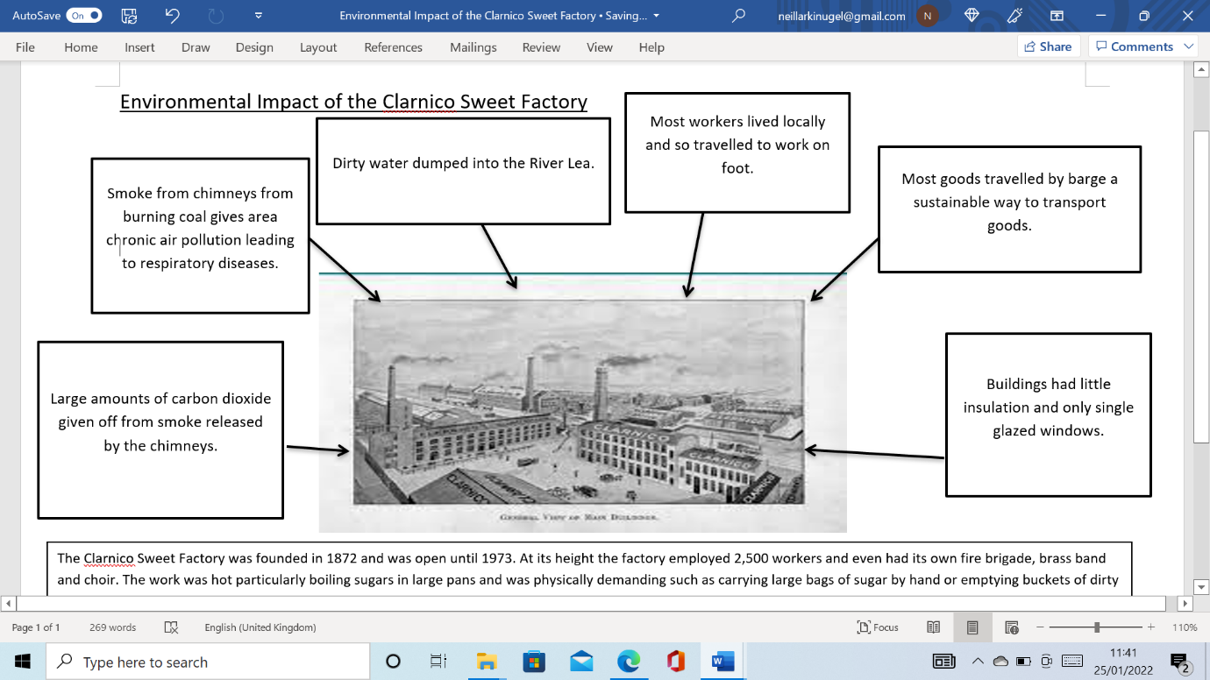
Figure 5: the teacher’s version of the worksheet
Key Points to Summarise
- This factory caused a lot of pollution, air, water and atmospheric.
- The building and its use showed little concern for the environment.
- Some of the positives e.g. low impact travel for the workers or transporting goods by barge show good environmental features but are probably to do with the level of technology available at the time.
- This building reflects the industrial age when awareness of environmental damage was less common.

Activity 7: Plenary discussions (these could take place back at school)
Pupils discuss which of the three activities had the most impact on the environment and why.
Pupils are asked to explain how the environmental impact of different human activities has changed over time.

Additional teaching materials, trails and other resources can be found on Groundbreakers website, www.livingmaps.org/groundbreakers

