Environmental Impact of an Iron Age
Most of the activities e.g. pottery involved using natural materials that would not harm the environment.
Food was farmed locally so would have had a low impact on the environment.
Village
Lots of wood needed for building so this could have caused some deforestation.
People travelled on foot or by canoe. This would have had little impact on the environment.

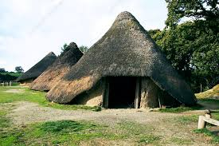
Around 2,200 years ago in 212BC an iron age village of around 100 people stood at the site that the Aquatic Centre now occupies. Houses were made from wooden stakes with walls covered in mud, and thatch roofs were made with reeds and straw. Food would have come from chickens, geese, goats, pigs, sheep, cows, wheat oats and vegetables. Activities would have involved fishing, farming, basket making from willow stems and making pottery from clay. Heat would have come from wood fires. Transport would have been on foot or dug-out canoe, made from a tree trunk. Several burials were found so the village was probably used for a long period.
Most building materials were natural so they would have had a low impact on the environment.
Wood fires would cause some air pollution.

Environmental Impact of the Aquatic Centre
Heat and light from the low carbon energy centre based in the park.
Users are encouraged to walk or cycle.
Centre is built on foundation of recycled materials.
Lots of windows provide natural light to cut down electricity usage.

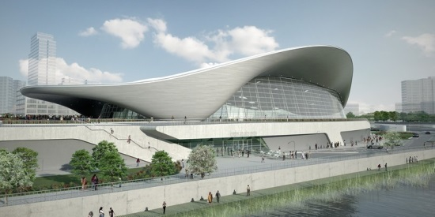
The Aquatic Centre was designed by Zara Hadid an Iranian architect who has since sadly passed away. Zara used the idea of a wave for her inspiration. In the 2012 Olympic Games and Paralympic Games all of the swimming and diving events took place here. The pools are now open to the public and are used by local clubs, schools and offer swimming lessons for children. The pools have excellent facilities for disabled swimmers. The current cost of a swim session is £5 for an adult and £3 for a child. The Aquatic Centre has a lot of windows to provide natural light, the timber used in the construction is from sustainable sources and the energy comes from the low carbon energy centre within the park. Further energy is saved by excellent insulation and techniques such as low-flo showers. The Centre is built on foundations made from 80% recycled materials. The pool has excellent facilities for bike storage and users are encouraged to walk, cycle or use public transport. Some people say that the building used too much concrete to be a sustainable building of the highest standard but others point out that the builders used replacement concrete where possible.
Timber used in the construction comes from sustainable sources (where the trees are regrown).
Building did use a lot of concrete which is not good for the environment. (Making cement gives off lots of Co2)
Environmental Impact of the Clarnico Sweet Factory
Dirty water dumped into water courses would have ended up in the River Lea.
Most workers lived locally and so travelled to work on foot.
Most raw materials travelled by barge, many of them horse-drawn, a slower but sustainable way to transport goods.
Smoke from chimneys from burning coal gives area chronic air pollution leading to respiratory diseases.

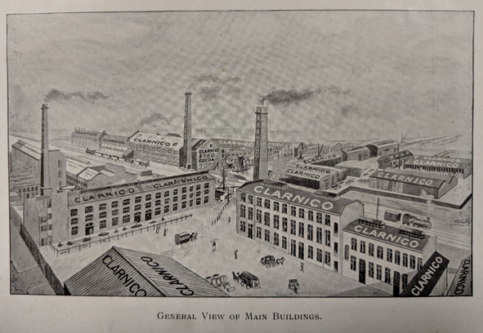
The Clarnico Sweet Factory was founded in 1872 and was open until 1973. At its height the factory employed 2,500 workers and even had its own fire brigade, brass band and choir. The work was hot particularly boiling sugars in large pans and was physically demanding such as carrying large bags of sugar by hand. Like many factories in the area, waste water would have drained untreated directly into to the nearby canals and river. The factory was made from brick with single glazed windows and poor insulation by today’s standards. The factory had three large chimneys which took away the smoke from large coal fires used for heat and for energy. This would have caused both air pollution in the local area and added lots of carbon dioxide to the atmosphere. The air would have smelt of smoke but also of peppermint and chocolate! Coal, sugar, cocoa beans and fruit were brought to the factory in barges, many of them drawn by horses which had low impact on the environment. Steam railways, ships and horse-drawn carts were also used to transport the finished sweets all over the world. Nearly all of the workers lived nearby in rows of terraced housing so had little distance to travel to work.

Large amounts of carbon dioxide given off from smoke released by the chimneys.
Buildings had little roof insulation and only single glazed windows.

