Risk and Resilience in London: worksheets

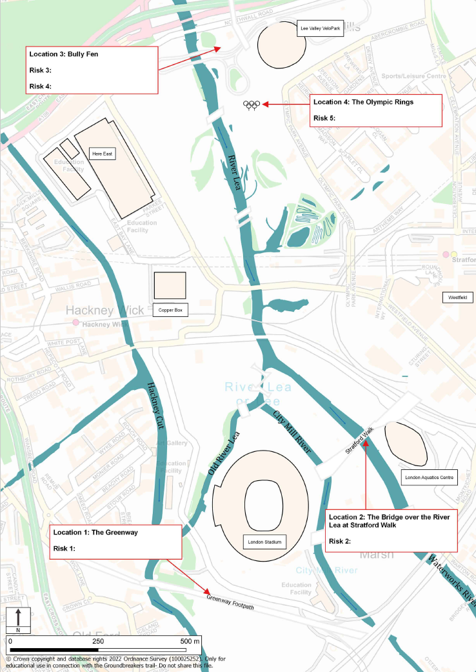

Risk 1: Disease Date:_____

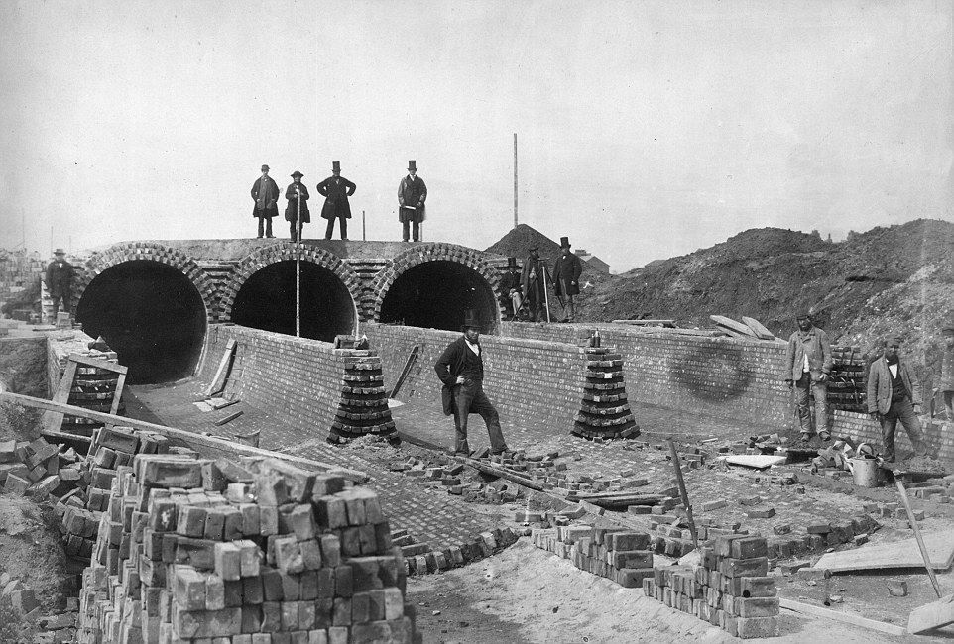

The sewer that Joseph Bazalgette built runs through the Olympic Park

Description of risk and solution:

How severe was the risk? (10)

How often did the risk occur? (10)

How effective was the solution? (10)

How expensive was the solution? (10)

Risk 2: Flooding Date:______
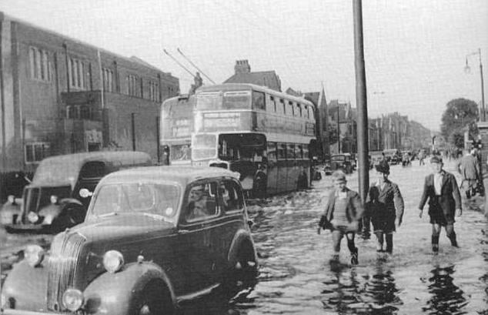
The River Lea and linked channels flow through the Olympic Park.
Description of the risk and solution:

How severe was the risk? (10)

How often did the risk occur? (10)

How effective was the solution? (10)

How expensive was the solution? (10)

Risk 3: The Blitz Date: _____

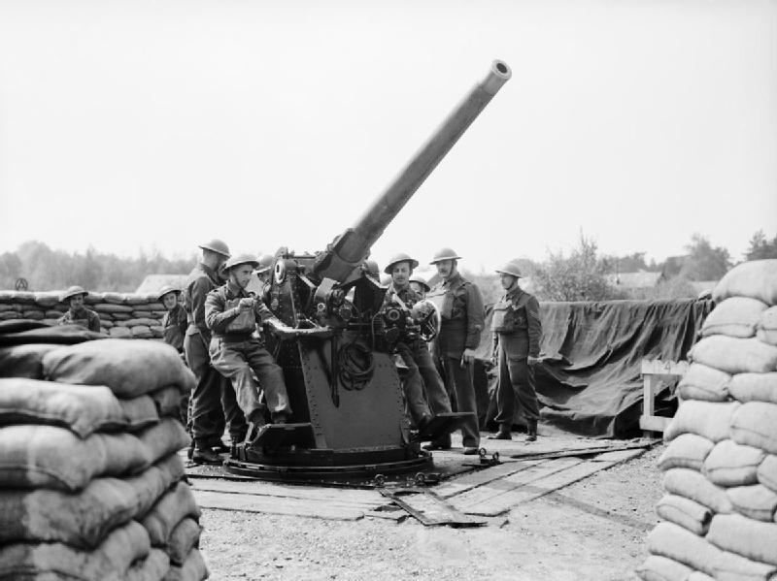

Anti-Aircraft Guns where stationed near where the Velodrome now stands
Description of risk and solution

How severe was the risk? (10)

How often did the risk occur? (10)

How effective was the solution? (10)

How expensive was the solution? (10)

Risk 4: The Cold War Date:______

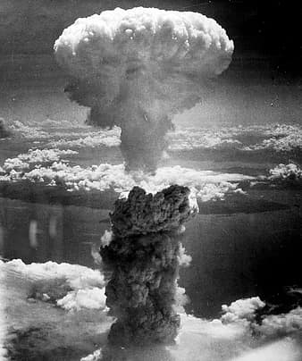
London’s Civil Defence Corps ran training emergency rescues on the site near the Velodrome to practice for nuclear war.
Description of risk and solution:

How severe was the risk? (10)

How often did the risk occur? (10)

How effective was the solution? (10)

How expensive was the solution? (10)

Risk 5: Global Warming Date:_____

Many features of the Olympic Park are designed with this risk in mind.
Description of risk and solution:

How severe is the risk? (10)

How often did the risk occur? (10)

How effective was the solution? (10)

How expensive was the solution? (10)

