The Queen Elizabeth Olympic Park: Risk and Resilience in London
This lesson/activity plan is designed to be taught in situ inside Queen Elizabeth Olympic Park. They have been designed by an experienced teacher for use with young people aged between 11 and 14 and they are aligned with the National Curriculum for Key Stage 3. The plan includes four sites and can be comfortably completed in a half-day visit. It involves a fairly long walk around the full length of the Park – at least an hour of walking is involved, but this can be broken up visiting other Park features.

Preparation/required resources
For background and additional information about the sites chosen for this plan and other park features you may find bookmarking the online (and mobile phone friendly) Groundbreakers map and guide useful. The Queen Elizabeth Olympic Park website is also essential viewing for the latest Park map (including location of toilets and cafes), and also useful to keep you informed any organised activities or events that may have an impact on your visit and the Google map illustrated below with a suggested route might be useful. We suggest you bring a tablet, laptop or mobile phone to play the YouTube videos. An external/Bluetooth speaker might be useful for bigger groups. Otherwise you just need to print out the accompanying set of worksheets (one set per pupil) and provide pencils/pens.

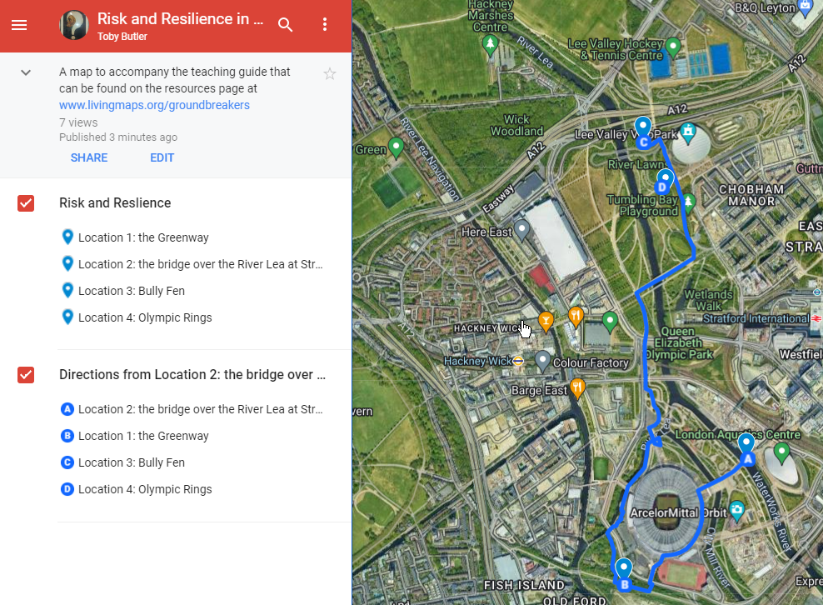
Figure 1: A possible route to visit all four locations, via Carpenter’s Road Lock (a major flood defence).

Objectives
To give pupils an understanding of historical and contemporary risks faced by London and how in the past and now the threats have been and are being addressed.

Instructions
This activity plan is based on the game of ‘Top Trumps’. Most people will be familiar with this card game which is published for a variety of themes. For example, different types of dinosaurs might be graded on their weight, height, ferocity and speed. The first player picks a category - say weight - and if their card has the heaviest weight, they win their opponent’s card. The game continues until one player has all of the cards.
In our version, the aim is to provoke discussion and thinking rather than get 'right' answers. However, most would judge the threat of flooding on the Lea as having a lesser impact than the threat posed by the Second World War. At each site the pupils should write a description of the risk and its solution. They should then record their values out of 10 for each of the categories covering scale of risk, frequency of risk, effectiveness and cost of solution. These judgements are all open to debate and should create some lively discussion.
These notes are intended to provide some background context for teachers leading a group of pupils through the Park. They are not exhaustive. At some sites there is visible evidence of the risk or solution. At other sites all traces have been removed. At sites with no visible traces, a video link is embedded to aid pupil understanding, which could be played on a tablet, laptop or mobile phone, perhaps with the aid of an external speaker (there is free wi-fi available throughout the Park).
There are five risks and four locations to visit (in any order); at each site, give the group some contextual information and ask them to fill out the relevant risk(s) for that point on the map, and then fill out the relevant card with their scores. In groups of two or three, ask them to compare their scores and discuss any differences (this might also work as a whole group discussion if you prefer). Once they have the set filled out, they can play the game (again, groups of two or three). If players draw the same card, one pupil should move to the next card in the ‘pack’ until they are different.
The worksheets, additional teaching materials, trails, more information about these and other features in the Park and an Augmented Reality trail for mobile devices can be found on Groundbreakers website, www.livingmaps.org/groundbreakers

Location 1: The Greenway (Risk 1: Disease) 1875
In the mid-nineteenth century, London had no sewer network, and this was increasingly recognized as a major contributory factor in the highly frequent outbreaks of deadly diseases such as Cholera and Typhus. The city’s rivers were open sewers, including both the Thames and the River Lea. A major outbreak of Cholera in 1853-1854 claimed 10,000 lives across the city and finally provided a key stimulus for the civil engineer Joseph Bazalgette to design a sewer network. Meanwhile Parliament was finally driven to take action by the Great Stink of 1858, when the smell of the Thames made working in Westminster unbearable. Eventually completed in 1875, the development of this network was instrumental in a rapid and dramatic improvement in public health. The estimated cost of this development at today’s prices is £750 million. The Northern Outfall sewer is still operational, and what is now the the Greenway cycle/footpath is actually an earth embankment supporting pipes that transport London’s sewerage (the pipes are visible where the Greenway bridges roads and canals).

Location 2: Overlooking the River Lea (Risk 2: Flooding) 1947
In 1947 following a period of heavy rain that coincided with melting snow flowing into the River Lea there was extensive flooding in the streets around Hackney. An area equivalent to 4,000 football pitches was underwater. Roads were unpassable, hundreds of thousands of homes had no fresh water and railways were closed. People had to be evacuated from their homes by boat and local businesses lost thousands of pounds of income. This had happened before in 1918 and 1928. As a result of the 1947 floods large engineering works were started that involved the construction of a separate channel to take away excessive water and the construction of locks and sluices to hold the water. The cost £82 million by today’s standards.
In a separate development as part of the improvement to the Olympic Site the valley of the river was reshaped to give a far more gentle gradient. This creates wildlife habitats that can cope with flooding and will hold water reducing the flood risk downstream. This reshaping allows the river banks to be used for leisure activities.

Location 3: Next to the Velodrome (Risk 3: World War Two) 1939 – 1945
Video: London's Biggest Blitz (1941)
Britain was at war with Germany from 1939 until 1945. The Blitz was an intense bombing campaign that Germany launched against Britain in 1940, during World War II. For eight months German airplanes dropped bombs on London and other strategic cities where factories and other important industries were based. The attacks were authorised by Germany’s leader, Adolf Hitler, and undertaken by the Luftwaffe, the German air force. The offensive came to be called the Blitz after the German word “blitzkrieg,” meaning “lightning war.”
Beginning on Saturday 7th September 1940, London was attacked on 57 straight nights. During that period alone, more than one million bombs were dropped on the city. The raids heavily targeted the Docklands area of the East End. This hub of industry and trade was a legitimate military target of the Germans. However, the Docklands was also a densely populated and impoverished area where thousands of working-class Londoners lived in rundown housing. The raids hurt Britain’s war production, but they also killed many civilians and left many others homeless. Although the attacks also hit the more prosperous western part of the city, the Blitz took an especially big toll on the East End.
At the beginning of the Blitz, the British lacked effective antiaircraft artillery and searchlights, as well as night fighters that could find and shoot down an aircraft in darkness. As the attacks continued, the British improved their air defences. They greatly boosted the numbers of antiaircraft guns and searchlights, and in key areas the guns were radar-controlled to improve accuracy. The anti-aircraft guns shot down relatively few German planes but probably caused German pilots to drop their bombs off target. Bully Fen (next to the Velodrome) was the site of 4 anti-aircraft guns.
The Blitz was devastating for the people of London and other cities. In the eight months of attacks, some 43,000 civilians were killed—more than two-thirds of the total civilian deaths for the whole war. One of every six Londoners was made homeless at some point during the Blitz. Nevertheless, the campaign proved to be a strategic mistake by the Germans. The attacks contributed little to the main purpose of Germany’s air offensive—to dominate the skies in advance of an invasion of England. By mid-September the RAF had won the Battle of Britain, and the invasion was postponed indefinitely. On May 11, 1941, Hitler called off the Blitz as he shifted his forces eastward against the Soviet Union. Hitler’s intention during the Blitz had been to break the morale of the British people so they would pressure their government to surrender. Morale indeed suffered amid the death and devastation, but there were few calls for surrender. The phrase “Business as usual,” written in chalk on boarded-up shop windows, exemplified the British determination to carry on as best they could.
At the end of World War 2 Britain had a debt of £21 billion which equates to a staggering £966 billion at today’s prices. The last part of this debt was paid off in 2006.

Location 3: Next to The Velodrome (Risk 4: The Cold War) 1960’s
Video: 700 Practice Civil Defence (1963) - YouTube
After World War II the United States and the Soviet Union were the superpowers of the world. They became rivals as they each sought to prevent the other from gaining too much power. The period of tension that existed between them came to be known as the Cold War. Although the conflict did not result in actual war between the two countries, it did lead to a number of proxy wars.
During the Cold War there were very serious worries that a nuclear war might break out between the United States and its allies, including Britain on one side with the Soviet Union and its allies on the other.
Between 1953 and 1968 Bully Fen (near to the Velodrome) became a Civil Defence Corps training ground and was used for the defence of London, though this time it was run by civilian volunteers rather than soldiers. The Corps were set up by the Home Office in 1949 to counter the threat of nuclear war and the site was used to train volunteers to rescue and care for people in the aftermath of expected atomic bomb (and later, hydrogen bomb) attacks on the UK. An entire ‘ruined’ village was constructed at Bully Fen for volunteers to practice at ‘saving’ people from bombed-out rooms and to learn how to dig out casualties from piles of rubble, while volunteer nurses and a welfare section provided first aid and field kitchens. The training site initially reused roads and buildings from the anti-aircraft defences but later saw around 20 purpose-built ‘ruined’ structures erected. These included an array of mocked-up residential and industrial buildings, some of which reused real rubble, doors and furniture from buildings that had been bombed during the Second World War.
The UK defence budget in 1960/61 was £1.6 billion, equivalent to £40 billion today.

Location 4: The Olympic Rings (Risk 5: Global Warming) 1980’s Onwards
The Earth’s temperature is heating up. Governments around the World have committed to try and limited global warming to 2 degrees. The cost to Britain is estimated to be £20 Billion per year until 2050. There are many features of the Olympic Park that try to mitigate the impact of global warming:

 | Feature | How It Works
1 | The Energy Centre | The energy centre creates low carbon heat and electricity for the buildings in the park.
2 | 2,000 trees | Trees soak up carbon and provide shade on sunny days.
3 | 30,000 wetland plants | Help to prevent flooding and create wildlife habitats.
4 | Cycle routes | Cycling is a green way to travel.
5 | Venues built on foundations which used rubble from the old factories. | This saved the transport of the old materials and the carbon cost of making and transporting new materials.
6 | Recycled gas pipes used to construct main stadium | Saved the carbon cost of making new tubing.
7 | Rainwater harvesting | Water collected from the roof of the velodrome is used to flush toilets. This saves the carbon cost of purifying water.
8 | Bat boxes | Help biodiversity.
9 | Sustainable timber | Timber from sustainable sources means that the trees are regrown.
10 | Natural Light | Glass sides on the Aquatic Centre and skylights in the Velodrome reduce the need to burn electricity.

